EU DECLARATION OF CONFORMITY

Distributor: Address:
CIF (VAT number):
JBM CAMPLLONG, S.L.

CIM La Selva – Crta. Aeroport Km 1.6 Nave 2.2, 17185 Vilobí d’Onyar, Girona B17419292
2 UNITS 6T AXLE STANDS SET


Description of the product:
53779
Distributor’s reference:
2006/42/EC
The object of the declaration is in conformity with directives:

And the following standards:

EN ISO 12100: 2010

Signed by:
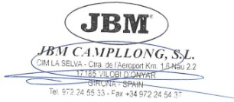
Eduard Godoy
Purchasing Department Director
Date: 15/05/2025

